Names and NSIDs: Yinsheng Dong (yid164); Ruida Xie (rux793); Hao Li (hal356);
Project: jEdit
Change Number: [6]
Date: 04/05/2018

Everything in italic should be changed as appropriate by you and should not be italic when submitted.
(Show/Hide whitespace)

- Change Request：
Currently jEdit shows a red dot at the end of every line. Newline is the only whitespace symbol that jEdit shows. Add menu item Show/Hide whitespace under menu View to allow the user to choose whether all whitespace symbols (newlines, blanks, and tabs) will be shown. At this stage you do not have to worry about editing of the text with whitespace showing.

- Concept Location:
Firstly, I analyzed jedit_gui.prop in the org.gjt.sp.jedit package It is known that every menu option is stored in this file, so I kept track to around 470 line in this file, and I found “View menu”. Every view menu item is in this location. Secondly, I checked how the menu function works. I found every menu item is executed by actions.xml in the package JEdit.org.gjt.sp.jedit, so I know it is needed to add action code in this file. The next thing I did is to find TextArea class in the org.gjt.sp.jedit.textarea package, because add/hide whitespace is executed in the TextArea.
Explain the methodology that you have used to locate each concept that was part of your change request. Using Table 1, list all the files in the order that you have visited them (2nd column). Explain how you have found each file (3rd column). You can simply read the source code, but we encourage you to use the features provided by Visual Studio: “Quick Find”, “Find Symbol”, “Go To Definition”, “Call Browser”, “Find all References”, ”Class View”, “Insert Breakpoint”, or any other software tools that you want to use.
In the forth column, mention if the class is related to the concept. Use one of the following terms:
- Use “Unchanged” if the class has no relation to the concept but you have visited it.
- Use “Propagating” if you read the source code of the class and it guided you to the location of the concept, but you will not change it.
- Use “Changed” if the class will be changed.
In the fifth column, write what you have learned about the class.

Table 1. The list of all the classes visited during concept location.
# | File name | Tool used | Located? | Comments
1 | jedit_gui.prop | Eclipse Searching (files) “interface definition” | Changed | Every menu item and interface component are in this file, so I kept track to around 470 line in this file, and I found “View menu” So I think the show/hide white space should add in the menu.
2 | actions.xml | Eclipse Searching (files) “actions.xml” | Changed | I looked over this file, and I found this file can handle TextArea method, and execute function here, because we need to add a new item in the view, and do hide/show whitespace method, so some code will be added in this file
3 | TextArea.java | Simply read | Changed | I looked over this TextArea panel class. After 270 lines, I found there are many text area method is written in this file, so if I want to add new java function, this is the place that I can write in.

- Impact Analysis:
Using table 2 list the classes that you visited after you located the concept. On the first row, include the class where you have located the concept, i.e. the class that will be changed (2nd column). Explain how you have found each of the classes, i.e. which tools have you used (3rd column). Do you think that the class will be impacted by the change? (4th column). Write short comments explaining what have you learned about each class. What other tools you would like to have in Visual Studio so that impact analysis would be faster

Table 2. The list of all the classes visited during impact analysis.
# | Class name | Tool used | Impacted? | Comments
1 | jedit_gui.prop | Eclipse Searching (files) “interface definition” | Change | UI parts are in this class. It needs to add “show/hide whitespace” menu item under the View menu
2 | actions.xml | Eclipse Searching (files) “actions.xml” | Change | Functions are executed in this file, it will be needed to add actions code.
3 | TextArea.java | Simply read | Change | This class is use to show the text area and do some implementations.
4 | JEditBuffer.java | Get from parameter from TextArea.java | Propagating | This file represents the contents of an opened text file
5 | TextAreaPainter.java | Get from parameter from TextArea.java | Propagating | This file is the component responsible for displaying the text of current buffer

- Learning process: Include a partial UML class diagram. The class diagram must contain all the classes that you visited and all the relations (dependencies) between the classes that you understood. (see Figure 1). Mark the classes that were changed with red text as in the example.
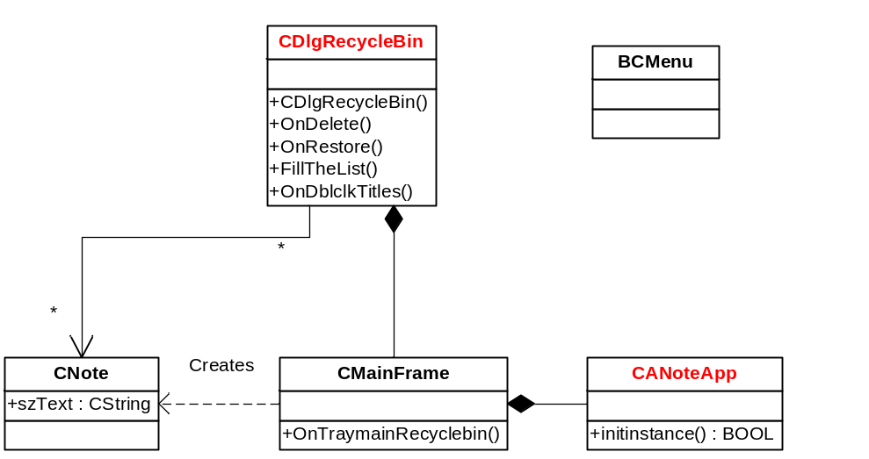
Figure 1 Example of the class diagram

- Description of the implementation:
Explain where and why you made changes in the source code. Which classes or methods you created, or changed

- Sources: Include any sources that you cited or used information from

- Highlighted Source Code: Attach or cut and paste the code of the classes that you changed. Highlight the code that was changed or added. Use YELLOW for modified code RED for deleted code, and GREEN for added code. If you only changed one method in a large file, only include that method and the file name it’s from. Likewise, if you only changed a line or two in an event map or resource file, only include a few of the surrounding lines and the file name. Do not include thousands of lines of code that you did not change!

